# Experiment No 8 PART A

# Objective: Design an IOT system based on ESP32 to measure soil wetness for the agriculture application

**Components required**

1. ESP 32 Module
2. Soil Sensor Module (resistive or capacitive type)
3. System with IDE software (latest version)
4. USB cable
5. Breadboard and jumper wires
6. LED

**Procedure**: In this experiment, we are going to interface a Soil moisture sensor with an ESP32. This sensor measures the wetness of the soil and gives us the moisture level as output. The sensor is equipped with both analog and digital output.

The soil moisture sensor consists of two probes which are used to measure the volumetric content of water. The two probes allow the current to pass through the soil and then it gets the resistance value to measure the moisture value.

When there is more water, the soil will conduct more electricity which means that there will be less resistance. Therefore, the moisture level will be higher. Dry soil conducts electricity poorly, so when there will be less water, then the soil will conduct less electricity which means that there will be more resistance. Therefore, the moisture level will be lower.

Input Voltage: 3.3 – 5V  
Output Voltage: 0 – 4.2V  
Input Current: 35mA  
Output Signal: Both Analog and Digital

Pin Out: The soil moisture sensor has four pins:

VCC: Power  
A0: Analog Output  
D0: Digital Output  
GND: Ground

The Module also contains a potentiometer which will set the threshold value. This threshold value will be compared by the LM393 comparator. The output LED will light up and down according to this threshold value.

To connect the sensor in the analog mode, we will need to use the analog output of the sensor. When taking the analog output from the soil moisture sensor, the sensor gives us a value from 0 to 4095. The moisture is measured in percentage, so we will map these values from 0 to 100 and then we will show these values on the serial monitor.

**Digital example**

To connect the soil moisture sensor in the digital mode, we will connect the digital output of the sensor to the digital pin of the ESP32. The Sensor module contains a potentiometer, which is used to set the threshold value. The threshold value is then compared with the sensor output value using the LM393 comparator which is placed on the sensor module.

The LM393 comparator compares the sensor output value and the threshold value and then gives us the output through the digital pin. When the sensor value is greater than the threshold value, the digital pin will give us 5V and the LED on the sensor will light up. When the sensor value will be less than this threshold value, the digital pin will give us 0V and the light will go down.

**Connections**  
The connections for the soil moisture sensor and the ESP32 in digital mode are as follows or it is your choice for selecting the GPIO pins.

[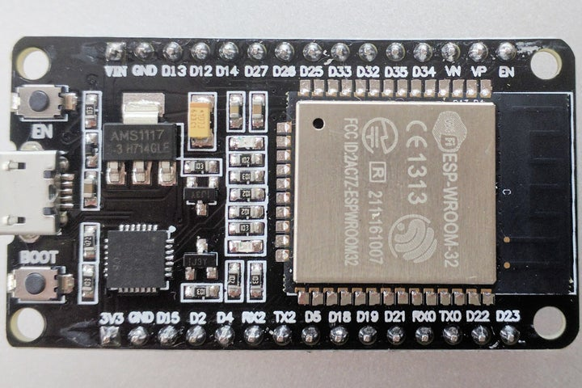](https://content.instructables.com/FR6/HY6B/JR0YT4HY/FR6HY6BJR0YT4HY.jpg?auto=webp&frame=1&width=1024&height=1024&fit=bounds&md=cb4278e931caf78c09cfc8d05ab443a0)

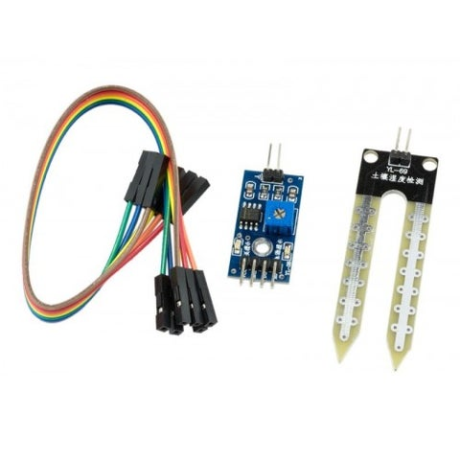

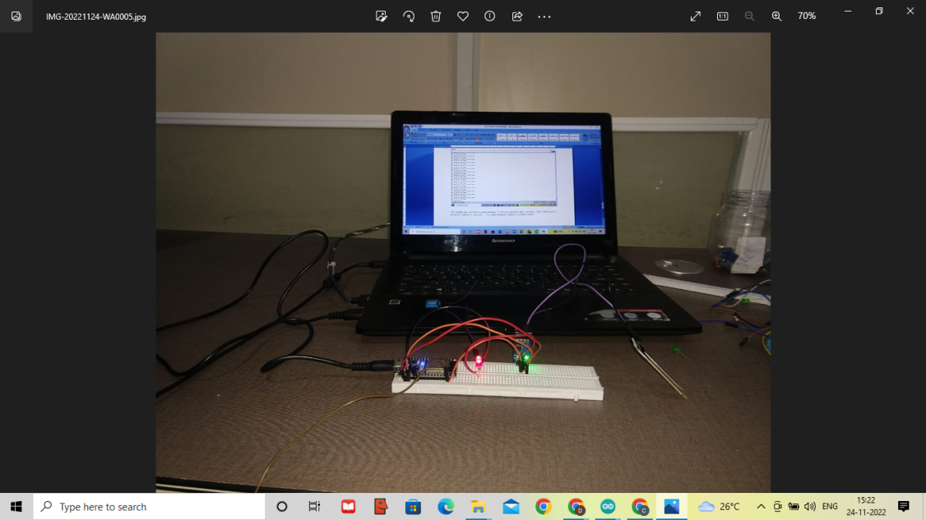

VCC of sensor to 3v3 of ESP32  
GND of sensor to GND of ESP32  
D0 of sensor to pin 36 of ESP32  
LED positive to pin 15 of ESP32  
LED negative to GND of ESP32

**Complete Code**

**int ledpin=22;**

**int sensorpin=23;**

**void setup()**

**{**

**pinMode(ledpin,OUTPUT);**

**pinMode(sensorpin,INPUT);**

**Serial.begin(9600);**

**}**

**void loop()**

**{**

**if (digitalRead(sensorpin)==HIGH)**

**{**

**digitalWrite(ledpin,HIGH);**

**Serial.println(“LED is ON ie RED light”);**

**Serial.println(“IT indicates no water in the field”);**

**}**

**else**

**digitalWrite(ledpin,LOW);**

**Serial.println(“LED is OFF ie. NO light from LED”);**

**Serial.println(“IT indicates there is water in the field”);**

**delay(1000);**

**}**

|  |  |
| --- | --- |
|  |  |

Results: The experiment is conducted and verified the results and is working well. If soil sensor is dry ie outside the water its resistance is high and the LED is ON (red light). If the sensor is in the water it shows low resistance ie. Indicates there is water in the soil.

The results are verified in serial monitor. If the soil sensor is dry it shows 1 (LED ON) and if is in water it shows 0 (LED OFF). The serial monitor display as shown below.

